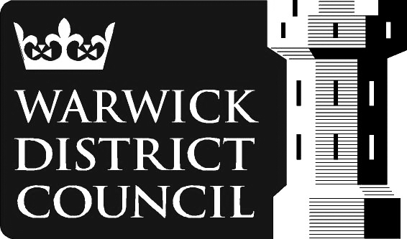
WARWICK DISTRICT
COMMUNITY FORUM GRANT FUND APPLICATION FORM

2017/2018
Please identify the community forum you are applying to:
Kenilworth | North  Leamington | South Leamington |  | Rural East | Rural West |  | Warwick | Whitnash
Name of applying group
Name of contact person, and postal address
Email address
Phone number
Describe what you want the money for. When do you anticipate you will have spent it all?
How much money are you  asking for, and what will you use it for?  - If you have to pay VAT you must include VAT in your total  - Will you have the correct level insurance in place (please confirm if appropriate) |  |  | TOTAL COST OF PROJECT = £  TOTAL SUM REQUESTED = £
 |  |  | ITEMISED LIST OF COSTS
Describe how much of your organisation’s own money or resources you are putting in. (If none, please say why.)
If you have applied for other grants for this work, tell us:
- how much
- where from
- if the grant has been awarded
If you have had any grants from any community forum in the last 12 months, please tell us what for, and how much. |  |  | Purpose of previous award from community forum grant fund, and name of forum |  |  |  |  |  | Amount
Describe the target group that will benefit.
- How many people will benefit?
- Who do you aim to benefit?
- How will you let people know about your activity?
Which geographical area will you focus on? (e.g. a neighbourhood or parish.)
If you are going to operate from a building, please tell us where it is.
Which community forum priority or local need will this grant address?
How do you know there is a need for the work covered by your bid?
- Describe the evidence you have got and where you got it from (e.g. survey, petition, statistical data, press cuttings, etc.)
Name any groups or agencies working with you on this. (Solo and partnership bids are both welcomed.)
Describe how you will prove that the work has been done, and demonstrate the impact it has had.
After the money is spent we will need to see:
- receipts
- evidence of delivery of the work
- numbers of people benefiting
- evaluation of the work
Does your group have its own bank account? (This cannot be an individual’s account.) |  |  | Yes |  |  | No
If ‘No’ to the above, give the name of the group or organisation that has agreed to administer the money for you
Date form submitted
Supporting Warwickshire County Councillor and Warwick District Councillor |  |  | Warwickshire County Cllr |  |  | Warwick District Cllr

