HILL TOP AND CALDWELL
BIG LOCAL PLAN
2019 – 2021

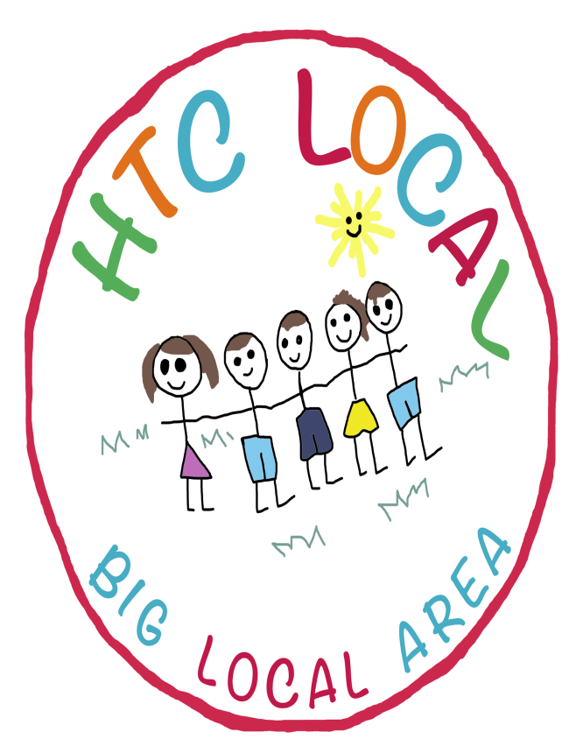

Version 1.5
Adopted 27/08/2019
1. Our Vision
Our vision is of a thriving active community where people of all ages are inspired to use our skills to bring the community together to tackle local needs, aspirations and achieve our full potential through a sustainable plan.
2. Hill Top and Caldwell Partnership Board
Our partnership board is made up of the following residents with many of them having been involved since we first started our Big Local journey:
- Ann Cox (Chair)
- Eileen Young (Vice Chair)
- Frank Seldon
- Bill Sheppard
- Jill Sheppard
- Carol Day
- Elaine Lovell
- Deanna Young
- Barbara Whitmore
- June Tandy
3. What is Big Local about?
The neighbourhood of Hill Top and Caldwell in Nuneaton was chosen in 2012 within the second of three waves of 150 areas across England to benefit from the Big Local programme.
Big Local is a £200 million Big Lottery funded programme that is managed by Local Trust. Our neighbourhood was chosen because it has in the past been overlooked by major investment and funding, was classed as ‘in need’ due to deprivation statistics and because community engagement is comparatively low to other areas.
The key features that make Big Local different to (and more exciting than) other programmes is that it is entirely community led, building on local talents and aspirations, creating a long term, lasting change using at least £1 million over at least 10 years.
Big Local has 4 clear outcomes:
- Communities will be better able to identify local needs and take action in response to them
- People will have increased skills and confidence, so that they continue to identify and respond to needs in the future
- The community will make a difference to the needs it prioritises
- People will feel that their area is an even better place to live
This plan explains who we are, what is important to us as a community, what we have achieved over the last two years and what we would like to achieve through the Big Local over the following two years.
4. Our Locally Trusted Organisation
Warwickshire Community and Voluntary Action (CAVA) is our Locally Trusted Organisation (LTO). They are the countywide infrastructure organisation for Warwickshire, providing support to the volunteers, groups, organisations, enterprises and charities who are working to strengthen communities across the county. Like us, Warwickshire CAVA is committed to providing services locally and accessibly. They have an office in our nearest town, Nuneaton, and have a dedicated local team of staff and volunteers we can call upon for support.
5. What have we achieved since 2017?
Our last Plan ran from 2017-2019. Here are some of the things we have achieved:
What we said we would do | What we did | What we didn’t do
Research to understand skills local employers are looking for | Commissioned person to do this work (37 hours per week). We attempted to make contact with local business by organising a business breakfast but this proved very difficult and challenging.  Free food safety course was organised for residents.  Employment advice has been offered on a regular basis through the Worker and a Job Club at the Community Centre.
Develop vocational skills training and develop bursary scheme if appropriate |  | This couldn’t happen until we had built relationships with local employers and done research.
Identify and work with local employers, to offer a range of opportunities, including apprenticeships, traineeships, work experience and school based industry learning |  | Similarly until we had built the relationship with local employers this work couldn’t happen.
Continue the Pot of Gold small grants scheme | We have continued with our small grants scheme and this has been very successful. There have been 9 successful awards made.
Encourage new groups and support existing groups. Promote local activities | Achieved through promotion on the Facebook page and newsletters.
Regular events – organise a programme of regular events in HTC to bring community together | We have organised pamper days.  Outdoor cinema event.  Summer fun day.  Skegness Trip.  Changing rooms art work.
Develop a half yearly newsletter for HTC and ensure that articles appear in other local newsletters and regular community publications | During this plan period we were only able to issue 2 newsletters due to time constraints.
Develop a welcome pack for new residents | We will be doing this before our plan ends in August.
Explore the feasibility of upgrading the play equipment to existing parks, creating an additional park in Caldwell, siting a youth shelter in Poyser Park and re-establishing the pod |  | This work hasn’t started; we have had difficulties contacting the relevant people within the Local Authority although we have recently made contact with someone who can help.
Recruit part time youth worker (16 hours) | Due to the lack of youth workers in the area we decided to commission activities out to other organisations.
Activities budget to support youth activity and buy in additional activity | We have commissioned both Nuneaton and Bedworth Leisure Trust and Wild Earth to provide a range of activities for young people.
Promote small grants scheme to existing groups to enhance their activity | Promotion has taken place and we have regular applicants to our Pot of Gold.  9 issued (more awarded but the groups did not take them up).
Continue with weekly healthy living sessions | Some activity did happen on this with the Healthy Living Network but they had to pull out of the service.
Develop inter-generational cooking activities |  | There hasn’t been time to do this.
Support Nuneaton and Bedworth Borough Council to improve access and signage at Gorsey Knob and upkeep of all green spaces |  | This has been left with the Borough Council and County Council to deal with and we will get involved if/when required.
Promotion of existing opportunities at the Pingles e.g. Passport to Leisure | This has been done and has proved quite successful. We made two Pot of Gold awards to facilitate this.
Support local centres to become effective ‘hubs’ provide funding to upgrade facilities (can be provided as match funding) | Funding has been provided to local centres:  - Fire alarm, defibrillator and support for the play and stay at All Saints  - Central heating system at Wembrook
People’s Pantry – support lifestyle checks, weight busters and other activities | This was happening until the Healthy Living Network pulled out.
Holiday hunger programme |  | We have found it very difficult to develop a fair way of accessing children who need this support without stigmatising them.
Offer community based, local access to generalist and specialist advice e.g. debt, welfare etc. | Commissioned WWRAS to do this work.
Continue to support Energy Angels who advise, share information and organise activities to promote energy efficiency and any other energy saving initiatives |  | Energy Angels haven’t thought of how to utilise the funding.
ATM Campaigns | This has continued and had some high profile coverage.
Training for Board Members | Board members have attended training and courses.
Website and Social Media | The website is up and running and the Facebook page is regularly updated and engages residents.

6. Where we are
The neighbourhood of Hill Top and Caldwell is located to the south of the market town of Nuneaton. There are 3 ‘sub-neighbourhoods’ which some identify with:
- Old Hill Top (the area to the left of Coventry Road on the map, Gilfil Road, College Street etc.);
- New Hill Top (the area to the right of Coventry Road to the canal, Knebley Crescent, Dorlecote Road etc.); and
- Caldwell (the area to the right of the canal, Caldwell Road, Red Deeps etc.).
To recognise these distinct identities we named the Partnership ‘Hill Top and Caldwell Big Local’, commonly known locally as HTC.
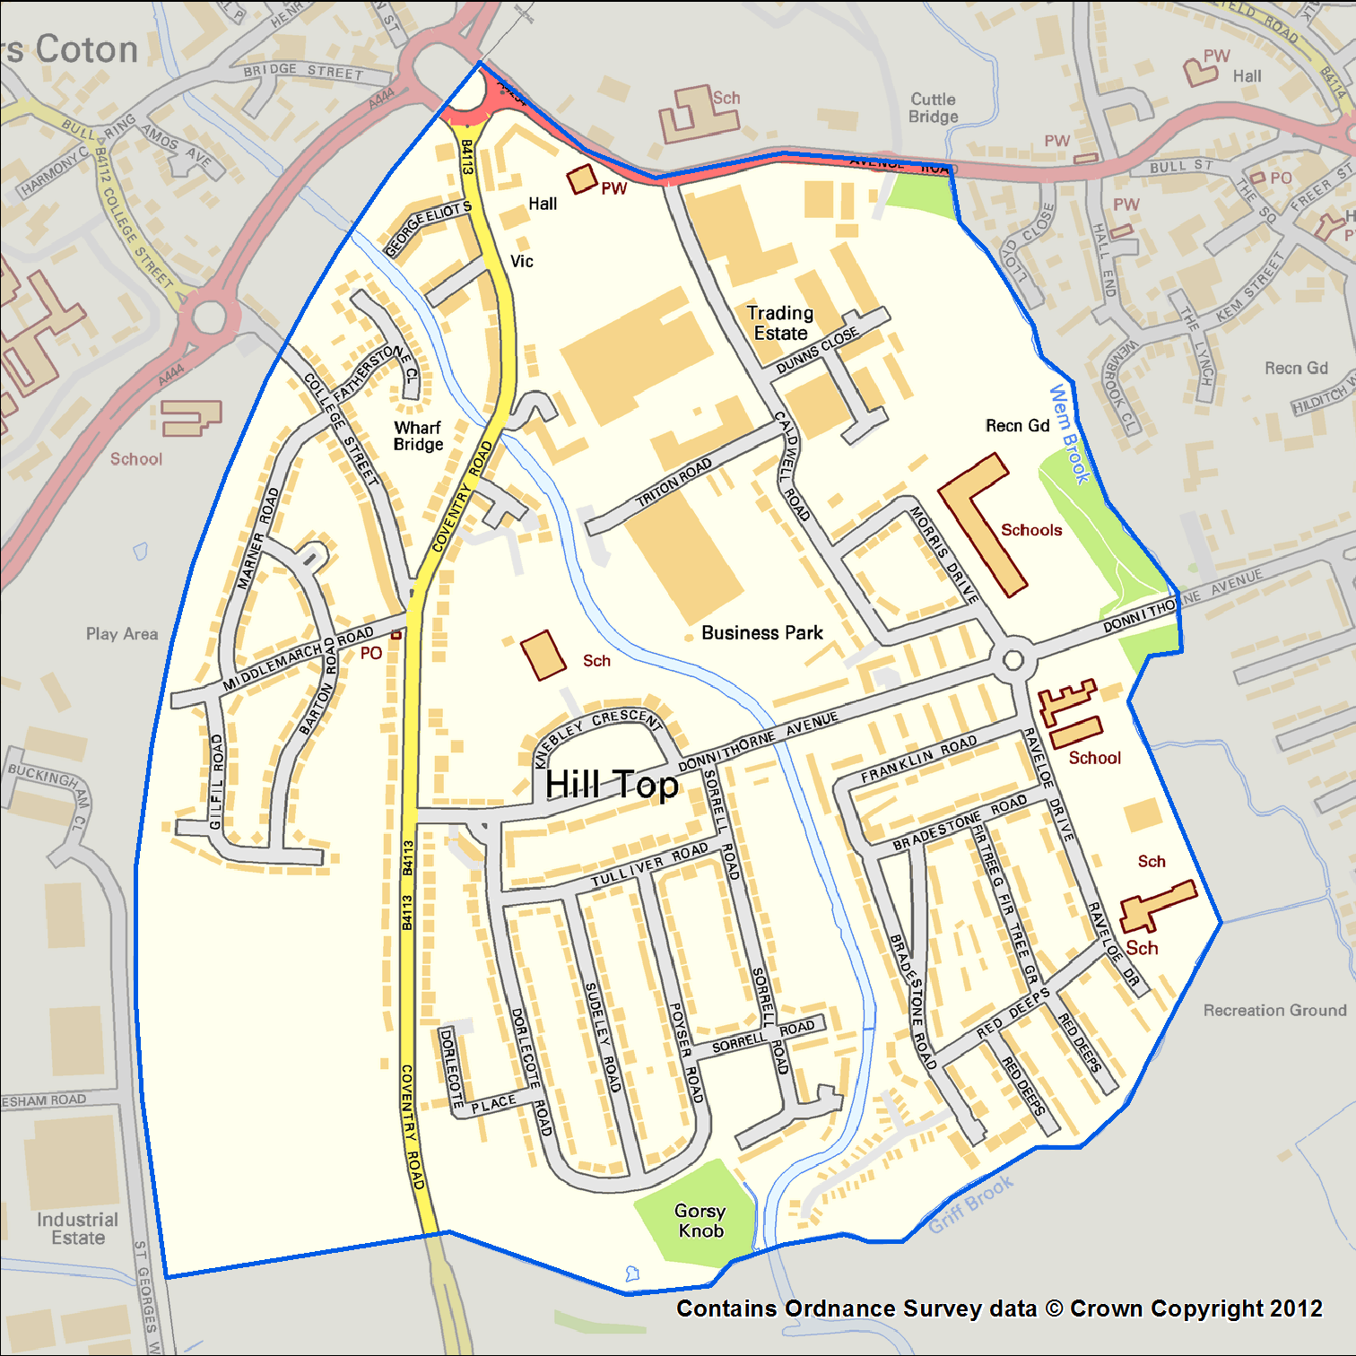
The local authority ward in which our neighbourhood is sited is called Wembrook. We have two-tiers of local government, with the Borough Council of Nuneaton and Bedworth (NBBC) and Warwickshire County Council (WCC). There is limited public transport infrastructure, yet usage and demand is high due to low car ownership. It is generally an urban area with some localised green spaces and open fields to the south of the neighbourhood boundary, locally known as Gorsey Knob and Griff Hollows. The area is accessible via close links to major roads such as the A444; Coventry Road is a main road that dissects the Big Local area literally and metaphorically.
Warwickshire County Council governs the non-metropolitan county of Warwickshire. Their Headquarters are located in Warwick. Politically the county is divided into five districts and boroughs; North Warwickshire, Nuneaton and Bedworth, Rugby, Stratford and Warwick. The Council’s principal functions are county roads and rights of way, social services, education and libraries, but it also provides many other local government services in the area it covers.
Nuneaton and Bedworth is a local government district with borough status, in northern Warwickshire, consisting of the densely populated towns of Nuneaton and Bedworth, the village of Bulkington and the green belt land in between.
7. The Hill Top and Caldwell area
It is evident that many local people do not define themselves by the statistics, many do not see themselves as ‘deprived’ (see information provided by Local Trust Local Insight Information created in May 2017) and they have very strong connections through history and family with the area. There may be a historical external perception that Hill Top is ‘rough’ and that there are certain families who cause trouble. Research carried out within the community to inform our first Big Local plan in 2015 found this not to be true. We also know that there are a high number of individuals and households that do not engage in services, activities, events and consultation; this was a common theme for us when we gathered the data to inform our first plan.
The Local Insight Profile* identifies that there are 3,775 people living in the Hill Top and Caldwell Big Local area compared to the 3,440 who were living there in 2017 when our plan was last updated.
33% of children are living in poverty in the Hill Top and Caldwell Big Local area compared with 20% across the West Midlands. A slight decrease has occurred over the last two years.
- 1% of households lack central heating compared with 3% across the West Midlands
- The overall crime rate is higher than the average across the West Midlands
- 23% of people have a life limiting long term illness in Hill Top and Caldwell compared with 19% across the West Midlands
- 38% of residents have no qualifications in Hill Top and Caldwell compared with 27% across the West Midlands
- 36% people aged 16-74 are in full time employment in Hill Top and Caldwell compared with 37% across the West Midlands. There has been a fall of 1% in the Hill Top and Caldwell area since our plan was updated in 2017.
- 34% of households in Hill Top and Caldwell have no car compared with 25% across the West Midlands. Again we notice a fall of 1% in our area since we last updated our plan
- The % of people ‘satisfied with their neighbourhood’ is lower than average across the West Midlands although 75% of Hill Top residents who responded to the Place survey were satisfied
As stated above there are 3,775 people living in the Hill Top and Caldwell Big Local area of which 865 are aged 0-15 which is a significant increase on the 770 of two years ago. 2,265 are of working age compared to 2095 two years ago. 640 residents are over the age of 65 compared with 570 two years ago. 90.5% (3,260 people) indicated that they are White British which is significantly higher than the West Midlands average of 79.2%. There are 190 lone parent families with dependent children living in the area. There are 220 children living in out of work households compared with 260 children two years ago (households where no member works and are claiming benefits), which still remains significantly higher than the West Midlands average. According to 2015 statistics 290 children living in the Big Local area are deemed as ‘living in poverty (33.4%) which again is significantly higher than the West Midlands average (19.8%) – there is a drop of 15 children in 2014. 435 children live in lone parent households.
There are 410 DWP Benefit Claimants living in the Hill Top and Caldwell area of which 245 are female and 165 are male. As of November 2018 there were 215 Universal Credit claimants. These figures are significantly higher than the West Midlands average.
According to the Index of Multiple Deprivation (IMD) 2015 there are 2,542 of Hill Top and Caldwell residents who are living in the most deprived 20% of areas in England. 2,542 of them live in the most deprived 20% of areas in England by income domain. 2,542 residents living in Hill Top and Caldwell live in the most deprived 20% of areas in England by health domain.
Since 2010 around 8% of the population claim incapacity benefits compared to 5.8% for the West Midlands. The number of unemployment benefit claimants (UC and JSA) is 4.4% for the area, compared with 2.9% for the West Midlands. However those claiming JSA for more than 12 months is the same rate as the West Midlands average at 0.6% - statistically the evidence suggests that nationally the vast majority of new JSA claimants find a job within 6 months.
Youth unemployment amongst the 18-24 year olds is currently 9.6% compared to 3.9% in the West Midlands area. The number of female and male JSA claimants is both slightly above the West Midlands average. The number of working age workless benefit claimants in the Big Local area is 265 (11.7%) which is also higher than the average for the West Midlands.
830 people who live in the Hill Top and Caldwell area have a limiting long term illness of which 445 are aged 16-64.
The percentage of residents eating a healthy diet (5+ portions of fruit and veg a day) is significantly lower in the Hill Top and Caldwell Big Local area (18.2%) compared with the West Midlands area (25.7%) and England as a whole (28.7%). However the percentage of residents who are known to smoke is significantly higher in the Big Local area (32.7%) compared with the West Midlands area (21.8%) or England as a whole (22.2%)
The number of children who live in the local area who are classed as obese when they are in the reception year at school is lower (8.6%) compared to the West Midlands area (10.4%) or England as a whole (9.4%). However by the time they reach year 6 this figure has risen to 19.8% which is slightly lower than the West Midlands area (21.5%) or England as a whole (19.4%). By the time they reach adulthood the figures has increased further to 30.7% compared with the West Midlands area (26.4%) or England as a whole (24.1%).
*Local Insight gives you access to interactive maps and reports at small area level. These reports show key social and economic indicators and allow you to compare the area selected to comparator areas.
Local Insight is a tool developed by Oxford Consultants for Social Inclusion (OCSI) based on a project developed jointly between OCSI and HACT.
OCSI develop and interpret the evidence base to help the public and community organisations deliver better services. A 'spin-out' from the University of Oxford Social Policy Institute, OCSI have worked with more than 100 public and community sector clients at local, national and international level.

8. Updating our plan
To help us update our current plan we commissioned Gill Hutchinson from MAC Associates in April to help us with this task. Unlike in 2017 when we had left ourselves a very tight timescale to produce a new plan, we were much more organised this time which has enabled us to do a much fuller consultation exercise.
8.1 Consultation with local residents and organisations
Discussions took place with Partnership Board members to determine what questions needed to be asked. The Board members were keen to understand if the priorities set for the first plan were still relevant.
A questionnaire was developed for local residents. We were then able to develop an on-line questionnaire as well as using it during our street consultations. Consultations took place at outdoor locations across the estate outside local shops, the post office, the Co-op and other locations. Partnership Board members took away questionnaires and did street surveys with residents living in their street. Some door knocking took place at some of the bungalows in the area. Consultation also happened at the outdoor cinema event on Easter Saturday. A total of 106 residents were involved. Whilst this number may not appear to be high it is evident from the consultation process that it still remains hard to engage people in this Big Local area.
Two stakeholder events were organised, the first which was close to Easter was not well attended with only 4 stakeholders present but the second a few weeks later resulted in 26 stakeholders attending.
8.2 What did people tell us?
Knowledge of Hill Top and Caldwell Big Local

It was heartening to meet a significant number of people who were already aware of Hill Top and Caldwell Big Local during the consultation events.

Despite many residents having heard about Hill Top and Caldwell Big Local there are still a significant number of people who are not attending events or not recognising that some of the events they are attending have been organised with Big Local funding.
During the consultation with residents we asked them how long they had lived in the area, the responses ranged from the shortest which was four months to someone having lived there for 76 years.
How well do you know your neighbours?

It is evident from the results above that there is a high degree of neighbourliness in the area. During the street consultations residents confirmed that they felt the area was friendly and welcoming.
Do you have friends and family living locally?

It is heartening to see that many residents have friends and family living locally, but it is evident from the previous chart that many get on very well with their neighbours and we know from other questions asked have lived in the area for a long time.
Do you feel lonely or isolated living here?

Despite many residents acknowledging that they get on well with their neighbours and a significant number of them have friends and family living locally, 24% of respondents admit to feeling lonely or isolated at some time. Reasons given for this include a perception that the area is not community minded. It was also highlighted that some elderly residents feel isolated as they feel intimidated by local teenagers. A suggestion was made that it would be good to have a “get to know your neighbours” event. In addition it was felt that if a regular coffee morning was established this would help people to not feel so isolated.
Perceptions of the local area

This question was developed to see if the work of Hill Top and Caldwell Big Local had made an impact on people’s perceptions of the local area. Additional comments provided by residents about why they felt this way indicated that they felt it had stayed the same or got worse because of the perception of the Council’s investment had disappeared. Concerns were raised about the level of anti-social behaviour in the area, that there is little for children and young people to do, the parks are not adequately maintained and don’t meet the needs of local young people and nothing has been done to raise the profile of the area. The issue of drugs and gangs in the streets were also highlighted. Concerns were also raised about issues outside of the area such as the number of shops closing in the Town Centre. It was highlighted here that there is a need for more activities and events for all ages.
Messy gardens, fly tipping and general deterioration of the area were highlighted as issues of concern.
However on a more positive note some residents felt that the incidents of anti-social behaviour had decreased. It was highlighted that the area had got a lot quieter and there were less young people hanging around.
“HTC involvement has aided to the improvement of the area”

Despite people indicating previously that the area is friendly and neighbourly it was highlighted here that there is poor community engagement and a high level of mistrust. We know that there have been more people from Eastern European backgrounds moving into the area so it could be that there are some barriers emerging because of difference.
8.3 Concerns, issues and suggestions raised by residents
During the consultation we asked people questions including:
- What other events and activities would you like to see happening in the area?
- If you had a million pounds what are the top three things you would spend it on to make your community happier?
- A total of 366 responses were made to these questions which are summarised below.
Children and Young People
Activities for children and young people/something for them to do featured heavily in the consultation responses with 21.9% (79 suggestions) highlighting this. 7.5% (27 suggestions) indicated that more family activities should be organised such as family fun days and weekend activities for all the family. 6 suggestions highlighted the need for holiday activities especially low cost or free activities. A small number of suggestions were also made regarding more activities for youth age, including putting some investment into the youth club. One comment indicated that there is a need for activities for younger boys, possibly an area just for them and offering more than just football.
Community facilities and activities
It is evident from the consultation that residents would like to have more opportunities to get together, socialise and take part in activities and events. Suggestions were made for more outdoor cinema events and outdoor theatre productions. In addition a small number of comments suggested holding a music event and a rave locally. A number of people have indicated that they would like to see more trips and outings organised and suggested that a seaside trip or a trip to a Christmas market would be supported. One resident suggested that it would be nice to have a community bonfire. Suggestions were also made to set up a craft group and to provide a place locally where the crafting community could buy supplies and attend craft workshops. A small number of suggestions highlighted the need for a swimming pool/water park. In the nearby Big Local area in Arley and Ansley the local sports centre is setting up a pop up swimming pool for the summer so it may be a good idea to talk to them about the logistics of setting up something like this.
It is not surprising given the lack of local facilities that a number of suggestions highlighted the need for a doctor’s surgery and a chemist/pharmacy. This featured in the previous consultations as well. It was highlighted that there is a need for more places for people to meet, however there are two centres in the Big Local area where this can happen. One suggestion indicated that it would be nice to have a more welcoming community centre and another suggested that there is a need for a Community Hub where people can seek advice, meet each other, house a library and be a place where people can meet for a coffee and chat. It was suggested that more activities should happen in Wembrook Centre.
A number of suggestions indicated that there is a need for more activities for older people. It was also suggested that it would be useful to organise some inter-generational activities to build bridges between the older residents and young people.
Additional suggestions included providing more shops, bring investment for businesses to come into the area, provide a library and a cafe run by local people. One suggestion highlighted the need for a shop for little people and another suggested that it would be good to have a new community facility that had a soft play area and a sweet shop. One person indicated that it would be nice to have a fairground visiting the area from time to time. One comment suggested that it would be good to organise a Food and Beer festival locally. A further suggestion indicated that it would be good to have a micro pub/bar in the area.
Parks and play areas
13% (48 suggestions) highlighted the need for improved/new parks in the area. The majority of comments indicated that the parks locally needed upgrading especially in Old Hill Top. It was suggested that there is a need for a park in the Caldwell area and on Knebley Crescent. Suggestions were also made to create picnic areas in the local parks. A suggestion was made that it would be good to have a zip wire installed in one of the parks and a further suggestion indicated that it would be good to have a skate park/bike park installed in the area. It was suggested that events should be organised in the local parks.
Environment
A suggestion was made that it would be good to hold a recycling event and organise an energy reduction campaign locally. Making the area look cleaner and better kept featured in the suggestions with suggestions for community litter picks to be organised. A suggestion was made that there should be a gardening event organised to tidy up local green areas. It was also suggested that the grassed areas and verges needed renovating. Concerns were raised about the dog fouling locally and it was suggested that there is a need to provide more bins for dog waste. One resident indicated that a community orchard should be established. It was also suggested that some money should be spent on the allotments locally.
Concerns were expressed about the amount of broken glass and rubbish that is left locally especially in the park and residents felt that this needed to be cleaned up more regularly as it provides a hazard both to children and animals. One suggestion highlighted a potential need to remove some trees from the park however they didn’t specify which park.
It was suggested that it would be useful to employ a part time gardener who could help people with their gardens, especially those who can no longer manage their gardens.
One person asked for more bat walks to be organised. One person also suggested that there is a need to maintain the wooded area and possibly create a picnic area here.
Employment
Concerns were expressed about the lack of opportunities for young people aged 16-25 and it was suggested that some training opportunities should be targeted at this age group. A suggestion was also made that a variety of vocational courses could be organised for all ages to include cooking, science, history and nature. Additional suggestions included:
- Organising job fairs locally
- providing community workshops to help with employment and education
Poverty
We know that is can be very difficult to determine the level of poverty in an area apart from using statistical information. During the consultation we asked residents a direct question about their family situation and the responses are detailed in the chart below.

It is evident from the chart above that the greatest number of respondents felt their situation had stayed the same however we don’t know whether this is a positive or negative situation for them. Almost one third of respondents did highlight that their situation had improved. Reasons given for situation improving include:
- got out of a domestic abuse relationship
- new babies arriving in the family
- children have got married
- started own family
- got a house
- found work
Only 12% of respondents highlighted that their situation had got worse and reasons for this included:
- outgoings increasing with income decreasing
- husband passed away
- financial worries/stress
- still living at home with a child
- husband not well/family illness
- loss of wife
- impacted by budget cuts
A number of suggestions made during the consultation highlighted help and support for homeless people. In addition it was suggested that a food bank should be established in the area. It was also highlighted that there is a need for some benefits advice sessions to be provided locally. More support for male and female lone parents was highlighted.
“help those in need who struggle to live day to day”

Health and Fitness
A number of suggestions indicated that some residents would like to see a green gym installed in the area. It was suggested that this would take away the need to have a gym membership and people could use it as and when they wanted to. It was also suggested that this facility should be ‘disabled friendly’. It was highlighted that there is a need to improve the health and wellbeing of residents living in the area. Suggestions also included the need for more sports activities to be available in the area and one person suggested organising community sports days.
Crime and Community Safety
Concerns were raised during the consultation about the street lights being turned off during the night. During the street consultations residents talked about the issues of drug taking locally and the impact this had on the community. Some have raised this as a concern in the surveys. It is evident from talking to people that there are concerns about groups of young people hanging around the area taking drugs and drinking especially in the local parks. In addition there are some residents who have drug-related issues where their lifestyle impacts on their neighbours e.g. constant visitors to their properties, poorly kept gardens etc. In addition some residents are concerned about needles being left in the local parks. General comments were also made about the need to tackle crime and anti-social behaviour. To overcome this it was suggested that there is a need for more PCSO’s in the area and a more visible police presence to tackle some of the issues of concern. It was highlighted that there is a need for more rigorous policing around Sorrell Park.
One resident suggested that gates should be installed to prevent motorbikes from riding through the cul de sacs. It was also suggested that safety fencing should be installed around the green on Donnithorne. Concerns were raised about speeding traffic and the difficulty of crossing the road near the bungalows. A suggestion was made that a crossing should be installed here. It was also highlighted that many cars don’t stop for the crossing patrols and road safety needs to be improved for children and young people. In addition it was highlighted that there is a need for road safety courses for children and young people.
General
A number of general comments were also made include:
- improve maintenance of properties in the area
- children should be in school between 9a.m. – 3p.m. not hanging around the area
- Create a pub
- Provide opportunities for boxing
- Sell local produce
- Provide something that can help shift workers
- Improve road surfaces
- Improve the quality of housing and community buildings
- Create a local currency
- Provide better public transport links
- Re-open the pod

8.3 What did local organisations tell us?
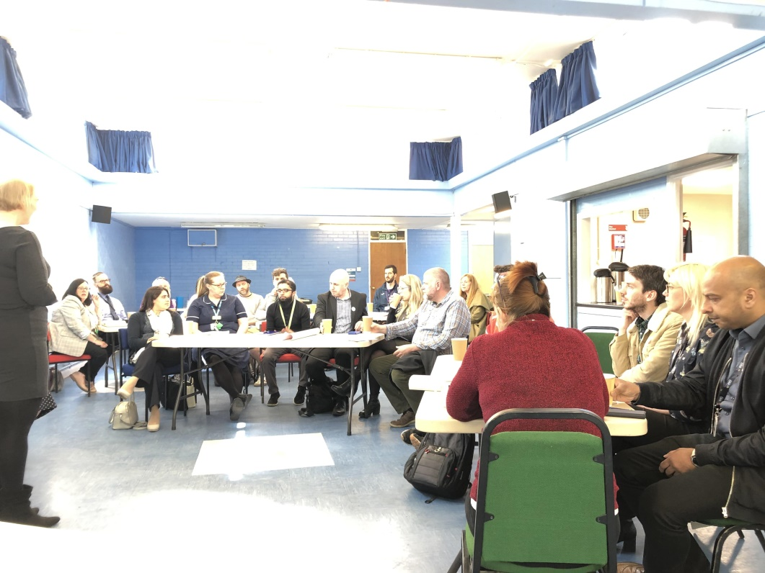
HTC Stakeholder Meeting 20/5/19
What is already happening in the HTC area?
- ‘Attleborough Matters!’ Community Group currently just working in the village producing a booklet covering activity/businesses but have future plans to extend in partnership with Warwickshire County Council
- Parent and Toddler Group and All Saints Church Hall – weekly session
- George Eliot Hospital Acute Services; closer to home care/more effective health care pathways
- Place based teams; weekly MDT (multi-disciplinary team) meetings to launch end June 19
- Care management/linking to alternative services, very responsive to local needs
- App (in partnership with Mary Ann Evans Hospice) to empower patients and carers
- Residential home support
- Emergency home visits
- WWRAS – working with All Saints and George Eliot Schools to increase take up of free school meals and work with Nuneaton and Bedworth Borough Council
- Assist individuals to claim/understand benefits entitlement
- Provide training on Universal Credit for residents
- WCAVA
  - Social prescribing service, supporting patients to access opportunities within the community.
  - Also providing infrastructure support for Voluntary and Community Sector.
  - Volunteering – Brokerage for individuals looking to volunteer; Mock interviews for Year 10 students linked with School Careers Adviser and NWHC encouraging volunteering as part of school/college course; Employer supported volunteering
- CSW Sport – mapping ideas, stakeholder and meeting planned. Funding available. Looking to contact Boys Club. Identify key people in the community
- NBBC – working with tenants and residents. Virtual network live – managed by residents to assist with housing functions. School work with George Eliot and HTC. Video project involving schools.
- George Eliot Hospital – Art for Health’s Sake – over 5 years social prescribing – art – health and wellbeing arts and crafts for staff and patients and in community i.e. Men in Sheds
- HTC Careers Advice – Business Breakfast, careers drop-in at Wembrook and All Saints Church. George Eliot career skills show. Offer of workshops in Careers Advice, Telephone, Customer Services, Food Safety Course.
- Independent Advocacy: hope to become involved in Community Development Project
- Digital Champions
- Access to training
- Access to Justice Advice
- Leisure Trust: school based sports events – stats show improvement
- Out of hours service Tuesday 6-9 Sorrell/Hill Top, Friday 5-8 same location
All age groups
- Saturday morning – help with local teams
- G E Fellowship – building on links
- George Eliot School – interested to find out where local area fit with school, possible pop up theatre, presentations (actors) including George Eliot School and other schools
- Positive Impact for Young People – Youth Organisation offering alternative provision (no longer operating)
- Wild Earth (CIC), Based in Spon End, Coventry
- Nature connection for young people and families (16-25)
- Running youth club on Fridays at Wembrook for 10-13 year olds
- Family connections days in the woods
- Pot of Gold growing project until December 2019
- Inter-generational growing project
- WCC Localities Team working in Hill Top, Attleborough, George Eliot, Caldwell, Nuneaton Central and Hospital area
- Supporting the George Eliot Bi-Centenary work with residents including the BBC TV Filming and BBC Radio 4 work
- Building people’s skills in the area e.g. Working with Elaine Lovell (HTC) to address ATM Poverty and other poverty issues
- Co-ordinating Services and supporting partners and Partnership development
- Environmental support to local projects, e.g. The allotments, Canal and River Trust litter picks with residents, Warwickshire Wildlife Trust – support to water vole project with Greenmoor Road Allotments
- Learning Disability Champion
- Dementia Friend
- Oakwood School – developing skills and promoting employment opportunities
- Strong team working to support families in the area and wider
- Provide apprenticeship opportunities for young people
- Offer specialist SEN Awareness/Training
- Open door for parents/community
- Specialist vocational resources – could joint work with local community
- Sycamore Counselling
  - Running two drop in sessions
- Anger awareness courses for adults
- One to One Counselling Centre – Adults and Young People
- Counselling therapeutic play for primary age children in schools, Centre and Early Help
- Providing one to one support for Orbit residents to help address any needs
- DWP – links to local employers, support to work clubs, Universal Credit awareness, support for Job Seekers
- Linking Futures – youth unemployment project, support and mentoring for young people 19-25
From your organisation’s knowledge of the area what else is needed?
Gaps in provision:
- There is no GP Surgery
- No local chemist
- Limited public transport, not available Sundays and Bank Holidays
- No family hub
- Access to closest ‘big’ supermarket is in the town centre
- Lack of social activities for families and adults
- No free ATM
- Neighbourhood identities – need to change from a barrier to a positive
What is needed?
- Greater support for Education and Skills
- Mental Health and Anxiety – crossover support to College/work
- Physical activity – outdoors working towards a goal, transferable skills
- Children and young people look at skills they have and jobs open to them – they need help and support to bridge the gap
- Parents/carers need to know what their children are capable of to help them
- Young people need new experiences – pushing limits, raising confidence
- Enable local people to obtain qualifications either academic or otherwise
- Enable local people to learn about the area (history) incl. Local parks
- Enable local people to know what their ‘rights’ are in relation to benefits/ local issues
- More regular and cheaper public transport
- People get help and answers from emergency services when they need it
- Better information about What’s On and What is available
- Tackle loneliness and isolation
- Long term condition management
- Raise aspirations
- We need to understand:
- why qualifications are lower in this area
- why are children living in poverty in this area
- we need to increase motivation and aspirations
- Generalist Advice (e.g. CAB) outreach – where to deliver from
- Understanding of how to connect with local people and get them engaged
- Free mental health support
- Support work clubs with Universal Credit Awareness
- Awareness sessions in Universal Credit – change the perceptions
Are Hill Top and Caldwell Big Local priorities still relevant? Is there anything else that is needed?
It was felt that the priorities are broad enough to meet needs outlined. It was identified that Hill Top and Caldwell were well placed to:
- Tackle elderly residents isolation and loneliness
- Find different ways to encourage children and young people to engage
- Make more use of school facilities in local area
- Provide a ‘Girls Only’ youth club to educate girls in the area and provide a space to talk about issues in a comfortable environment
- Carry on current projects/engaging community
- Priorities are broad enough and inclusive but need to have more focus on information sharing/ gathering (newsletters, new door app., activity/service books)
- Need more time capacity to start up activities and services
- More partnership networking – Police, Fire, WMAS, Nursing Teams – ability to increase links to those ‘seldom heard’
- Data sharing
8.4 Conclusions from the consultation
It is apparent from the consultation that resident’s and stakeholder’s priorities still reflect those outlined in the previous consultation with potentially more focus being placed on young people. Going forward the three areas of priority will remain:
- Increasing opportunities for employment and skills
- Increasing aspirations and community wellbeing
- Counteracting poverty
It is evident that there is a lot of activity happening in the HTC Big Local area by a range of stakeholders. Building relationships and developing partnership working even more than previously will enable HTC to capitalise on this provision and to ensure that they bring added value and do not duplicate existing provision. It is evident from the number of service providers who attended the two events that there is a strong desire to work with HTC.
9. Our Plan 2019-2021
Through the process of developing our new plan we have been able to reflect on what we have delivered and identify areas within our current plan that we have not yet achieved. There are many activities in our current plan that our residents tell us are still important and need to be addressed.
As a Partnership Board we continue to recognise that delivering our second Big Local plan has proved more of a challenge than we anticipated. We are aware that we do not always have the skills and knowledge needed to deliver some of the areas of work and recognise that we need to develop closer working partnerships with organisations that can guide and advise us. This is now becoming crucial so that we can deliver the things that local residents continue to tell us are important to them.
Through the process of developing this plan we also recognise that we do not have the time capacity to do everything ourselves so we have decided that during this forthcoming plan period we will commission out more activity so that it gets delivered. In addition we recognise that our current part time Worker cannot do everything, so we have also taken the decision to employ an Administration/support Worker for a few hours a week to free our other Worker up so that they are able to spend more time locally engaging with residents.
Four years into plan delivery we still find it hard to get engagement from residents. During this plan period we will aim to ensure that more events and activities are organised so that we build up a momentum and can keep the engagement going. In addition we are looking additional opportunities to engage with residents; we have identified that we could hire the ‘BOB’ bus (Branching Out Bus, owned by a neighbouring local authority) so that we are able to bring it into the HTC area and engage with residents.
Our last plan had an aspiration to find a local base which proved extremely difficult as there were no suitable vacant properties available. However, we have just become aware that one of our local shops could potentially become vacant shortly. Whilst residents have not asked us to develop a local hub we recognise that if we were able to create a base for HTC we could potentially increase the engagement of local residents. A shop window would enable us to advertise more effectively what HTC are doing and residents would be able to pop in and make contact with our Worker and partnership board members. Greater engagement in our work would also benefit other local assets such as All Saints Church Hall and Wembrook Community Centre because we would need to use their facilities more for our events and activities. If we are not able to secure the premises then we would anticipate using the ‘BOB’ bus regularly so that we were able to have a more visible local presence. We have budgeted for both in this plan.
Our LTO has indicated that they would look favourably at taking on the lease of the shop on our behalf until we are able to set up an incorporated body as part of our legacy and take the lease on ourselves.
9.1 Legacy, Monitoring and Evaluation
Hill Top and Caldwell Legacy
We are committed to upholding the principle of creating a legacy for the area when our Big Local funding comes to an end. During this plan period we will develop a Legacy Sub Group who will develop an understanding of what legacy means to HTC Big Local – is it about the people, ensuring physical assets are left behind or a mixture of both? The sub group will also draw up a plan of how legacy will be achieved.
Measuring our Impact
We will seek to evaluate our success by developing criteria based on our vision, value for money and sustainability. We will also ensure that we measure our ongoing success in relation to the four Big Local Outcomes:
- Communities will be better able to identify local needs and take action in response to them
- People will have increased skills and confidence so that they continue to identify and respond to needs in the future
- The community will make a difference to the needs it prioritises
- People will feel that their area is an even better place to live
We will ensure that we collect data regularly (either directly ourselves, or by making it a condition of any agreements with commissioned organisations) so that we know:
- How many people are attending our activities
- The age, gender and ethnicity of attendees
- Where they live in the area
- What change this activity has brought to them and their family
The qualitative information can be provided to us via case studies, quotes, short videos, photos of activities and events and evaluation reports.
We can then use this information to ensure that our promotion and publicity is reaching across the community. If we find that people are not attending activities from particular parts of the area we can then target that area more intensely to ensure residents are hearing about us and our activities. We will also ensure that the many stakeholders working in the area are also aware of what we are doing, well in advance, so that they can promote HTC to the local residents they are working with.
At every event we will either personally ensure or make our commissioned organisations aware that evaluation forms and more creative methods of collecting data are available so that people can let us know:
- If they enjoyed the activity
- If it met their expectations
- What would make it better, if anything
- What else could be provided in the future
- What change this activity has made to them and/or their family

9.1 INCREASING OPPORTUNITIES FOR EMPLOYMENT AND SKILLS
What do we want to change? | How do we want to do it?
1. Better access to and opportunities for local people to learn and develop skills | What’s the activity | What do we need to do? | Who? | Timescale | Cost  Year 1 Year 2
 | Develop vocational skills training and develop bursary scheme (small grants for individuals for job/ learning support) if appropriate | Based on information above provide vocational skills training locally | Project Worker  Partnership Board | March 2020 | £5,000 | £15,000
 | Fund additional time for careers advisers in schools | Liaise with George Eliot and Oakwood schools to provide this extra time for Year 9 + pupils. Ensure any offer is accessible for local residents not at these schools. | LTO and partnership board members to attend meetings | Commence programme November 2019 | £20,000 | £20,000
 | Fund sports based Target Group (accredited learning) at Wembrook Community Centre | Commission existing provider to extend this facility | Project Worker  LTO  NBLT  Wembrook CC | Continue programme from October 2019 | £5,000 | £5,000
 | Fund ‘Target Group’ (accredited learning) focussed on something other than sport | Prepare tender and commission appropriate provider | Project Worker, LTO, |  | £2,500 | £7,500
9.2 INCREASING ASPIRATIONS AND COMMUNITY WELLBEING
What do we want to change? | How do we want to do it?
1. Increased sense of community spirit, belonging, safety, and increasing community participation | What’s the activity | What do we need to do? | Who? | Timescale | Cost  Year 1 Year 2
 | Continue the Pot of Gold small grants scheme | Advertise half yearly for applications to Pot of Gold, ensuring activity is accessible/targeted to priority groups, e.g. families, older people | Small Grants Sub Group /Worker support | Half yearly | £15,000 | £15,000
 | Encourage new groups and support existing groups. Promote local activities | Project Co-ordinator to support the establishment of new groups | Project Worker/Partnership members | ongoing | No budget required
 | Regular events – organise a programme of regular events in HTC area to bring community together | Commission external organisations to deliver varied programme of events, ensuring activity is accessible/targeted to priority groups, e.g. families, older people | Events Sub Group, Project Worker, LTO | Develop tender documents October 2019 | £30,000 | £30,000
2. Increased awareness of HTC and what happens within the Big Local area | Develop 3 newsletters for HTC and ensure that articles appear in other local newsletters /regular publications | Produce a newsletter that is delivered to every household at least 3 times a year | Marketing and Comms Group, Admin Worker | 3 times a year | £7,500 | £7,500
 | Make good use of A boards (already purchased) to advertise activities |  | Marketing and Comms Group, Admin Worker |  | From budget above | From budget above
3. Increased provision of and participation in opportunities for all children and young people | Explore the feasibility of upgrading the play equipment in existing parks, e.g. in Old Hill Top, siting a youth shelter in Poyser Park, & exploring the feasibility of a new site in Caldwell | Meet with representatives from Parks and Open spaces to discuss the viability.  Visit other BL areas who have done similar projects  Commission appropriate expertise to undertake this work | Project Worker,  Partnership members | Commence January 20 | £5,000 | £100,000
 | Commissioned activity to meet the needs of young people outlined in consultation.  Undertake some research with young people about activities needed | Commission a range of ongoing activities and events to meet the needs of children, young people and their families ensuring a good range of activity including in all school holidays | Project Worker, Partnership Board members, LTO | Commence October 19 | £35,000 | £35,000
4. Our older residents feel more confident, less lonely and isolated and have activities to get involved in | Undertake research to identify what older people would like to do and what transport needs, if any, they may have | Survey of older residents | Partnership Board Members  Supported by Admin | Start October 19 | £500
 | Deliver a programme of activities that meet the needs of older and isolated residents | Ensure this priority group is addressed through events, Pot of Gold etc | Project Worker,  Partnership Board members  LTO | January 2020 | No budget required
5. We feel proud and use our green spaces more | Encourage litter picks across the estate to increase community pride | Bring groups of residents together to organise litter picks in their immediate area | Support from Project Worker  CSR – Local Companies | ongoing | £2,000 | £2,000
6. Our community feels safer | Crime prevention  Victim Support  Neighbourhood Watch | Ensure residents are aware of reporting processes and where to get help. Encourage residents to report crime  Support residents to develop neighbourhood watch schemes  Establish closer working relationships with relevant partners | Partnership Board  Project Worker  Newsletter  Website
7. Our community assets are more effective, with higher levels of community use and involvement | Support local centres to become effective ‘hubs’ – provide funding to upgrade facilities (can be provided as match funding) | Promote opportunities to local centres | Project Worker |  | £15,000 | £15,000

9.3 COUNTERACTING POVERTY
What do we want to change? | How do we want to do it?
1. Local people have access to good, affordable food | What’s the activity | What do we need to do? | Who? | Timescale | Cost  Year 1 Year 2
 | Encourage local shops to sign up to the Healthy Start vouchers | Make contact with local shops and find out why they are not participating | Elaine Lovell  Project Worker |  | £0 | £0
 | We want to ensure our children are not going hungry. | Establish whether the costs of existing breakfast clubs are prohibitive to some of our younger residents. If they are, give financial support to ensure greater access by our children who need the facility | Project Worker  Admin Support | March 2020 | £2,500 | £2,500
2. Residents are able to access affordable energy and energy saving advice | Work in partnership with organisations such as CAB to ensure that residents are getting the right advice and support  Work with local organisations to promote energy efficiency and other energy saving initiatives | Continue to provide room hire costs | Partnership members  Project Worker  LTO | January 2010 | £2,000 | £2,000
3. Residents are able to increase their household income and have more options around their finances | Offer community based, local access to generalist and specialist advice e.g. debt, welfare etc. | Identify and commission external providers | Project Worker  LTO | September 2019 | £12,000 | £12,000

9.4 Partnership Costs
Activity |  | Year 1 | Year 2
Part time Project Worker  Continue to employ a part time Worker (30 hours per week) to support the HTC Partnership in their plan delivery  Employ Admin Support (10 hours per week) to provide support to Worker and HTC Partnership Board  Costings include project management, use of office etc. |  | £38,623 | £40,908
Increase engagement and uptake in HTC activities and events. The following 2 options will be investigated | Access the ‘Bob’ bus on a regular basis: Find out availability; Research driver needs (licence etc.); Put a programme together of where it will be and when | £23,500 | £15,500
 | Access available shop in HTC area: Contact Agent/Local Authority; If available, instruct relevant professionals to get lease
Publicity and Promotion |  | £5,000 | £5,000
Website costs |  | £1,000 | £1,000
Training and Development for Partnership Board members |  | £5,000 | £5,000
Insurance |  | £ 700 | £ 700
Room Hire |  | £1,500 | £1,500
CONTINGENCY |  | £5,000 | £5,000
Total |  | £80,323 | £74,608

10. Breakdown of total costs requested
Priority | Outcome | Year 1 | Year 2 | Total
Increasing opportunities for Employment and Skills | Better access to and opportunities for people to learn and develop new skills | £5,000.00 | £15,000.00 | £20,000.00
 | Creating opportunities for local people to gain work experience and jobs | £27,500.00 | £32,500.00 | £60,000.00
 |  | £32,500.00 | £47,500.00 | £80,000.00
Increasing aspirations and community wellbeing | Increased sense of community spirit, belonging, safety and increasing community participation | £45,000.00 | £45,000.00 | £90,000.00
 | Increased awareness of HTC and what happens within the Big Local area | £7,500.00 | £7,500.00 | £15,000.00
 | Increased provision of and participation in opportunities for all children and young people this includes potential up to £100k capital play area renewal in yr2 | £40,000.00 | £135,000.00 | £175,000.00
 | Our older residents feel more confident etc | £500.00 | £- | £500.00
 | We feel proud and use our green spaces more | £2,000.00 | £2,000.00 | £4,000.00
 | Our community feels safer | £- | £- | £-
 | Our community assets are more effective with higher levels of community use and involvement | £15,000.00 | £15,000.00 | £30,000.00
 |  | £110,000.00 | £204,500.00 | £314,500.00
Counteracting Poverty | Local people have access to good, affordable food | £2,500.00 | £2,500.00 | £5,000.00
 | Residents are able to access affordable energy and energy saving advice | £2,000.00 | £2,000.00 | £4,000.00
 | Residents are able to increase their household income and have more options around their finances | £12,000.00 | £12,000.00 | £24,000.00
 |  | £16,500.00 | £16,500.00 | £33,000.00
Partnership Costs | Staff costs, running costs etc | £75,323.00 | £69,608.00 | £144,931.00
 |  | £75,323.00 | £69,608.00 | £144,931.00
Contingency |  | £5,000.00 | £5,000.00 | £10,000.00
 |  | £5,000.00 | £5,000.00 | £10,000.00
Total Amount requested from Local Trust |  | £239,323.00 | £343,108.00 | £582,431.00

Our thanks go to everyone who has been involved in putting this plan together, including the community members who took their time to talk to us, the Resident Board members for meeting with us and sharing their ideas, to staff at WCAVA, and to anyone else who we may have forgotten

