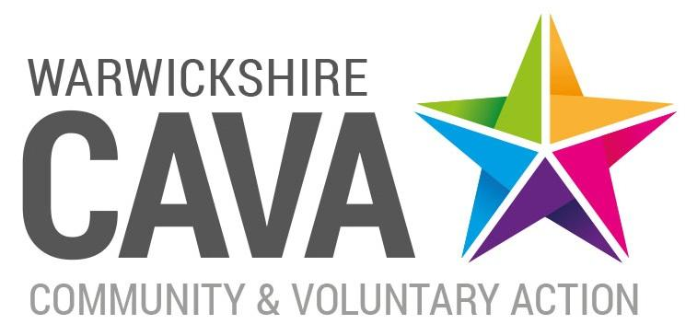
Trustee Role Description

Overall objective
Trustees of Warwickshire Community and Voluntary Action (WCAVA) are required to demonstrate a strong commitment to the voluntary and community sector and to the development of the organisation. Trustees will be collectively responsible for setting the strategic aims and objectives of the organisation; shaping and determining the organisation’s policies and policy direction in order to ensure it fulfils its charitable objectives; ensuring accountability to members and key stakeholders; delivering good governance and ensuring compliance with all legal requirements and financial regulations in accordance with Charity and Company law.

Task and responsibilities
- To be aware of, and confirm with, the responsibilities of a charitable Trustee and a director of a company limited by guarantee.

- To ensure WCAVA pursues its charitable objectives as defined in the Memorandum and Articles of Association and ensure it applies its resources in pursuance of those objectives.

- To ensure WCAVA complies with charity law and other relevant legislation and regulations and assessed the safeguarding risks that might arise from their charity's activities and operations.

- To be responsible for the monitoring and management of any risks, including financial risk, risk to reputation and risks associated with the delivery of the organisation’s activities.

- To ensure the effective and efficient administration of the charity.

- To ensure WCAVA’s financial stability by protecting and managing its property, funds and resources.

- To attend Board meetings (6 per year plus AGM) and committee meetings as appropriate.

- To actively participate in the work of the Board and contribute to its role in providing a strong strategic direction, defining and implementing policy, setting targets, monitoring and evaluating performance and ensuring the organisation’s work is consistent with its aims, objectives and values.

- To safeguard the good name, reputation and values of WCAVA, representing it and its stakeholders as appropriate.

- To sit on appointment and disciplinary panels and attend other internal meetings as appropriate.

- To support the Chair in the appointment, on-going support and performance management of the Chief Executive.

Person Specification and Conduct of Trustees

WCAVA Trustees are asked to:

- Demonstrate commitment to their responsibilities as a Trustee including attending Board meetings, scrutinising Board papers, attending the AGM and being available to staff and other Board members for advice and support as appropriate.

- Demonstrate an understanding and acceptance of the legal duties, responsibilities and liabilities of Trustees as laid down by the Charity Commission.

- Demonstrate a commitment to the aims and objectives of the organisation.

- Demonstrate a commitment to equality of opportunity and diversity.

- Operate as an effective team member; participate in all Board decision making, upholding the decisions of the Board.

- Demonstrate integrity and sound judgment.

- Use their skills and expertise to analyse proposals or plans pertaining to the development, growth or diversification of the organisation and to examine the financial consequences of those plans.

- Use specific skills, knowledge or expertise to assist the Board in achieving sound decisions. Provide advice, guidance and accurate information (based on individual specific expertise) on new initiatives and/or other areas of the charity’s work.

- Act as a representative of WCAVA at appropriate events including accurately representing the charity’s interests in order to raise the profile of the organisation and influence key stakeholders.

- Participate fully in all reviews of the Board’s working practices with a view to ensuring the Board operates effectively and has the expertise to ensure it meets its charitable aims and objectives, including participating in training and development.

- Respect the experience and expertise of staff and other Board members.

- Take responsibility for upholding WCAVA’s equal opportunities policy including not using discriminatory, abusive or offensive language or behaviour.

- Ensure effective communication between Board members and staff.

