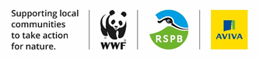
Wild Isles Community Fund
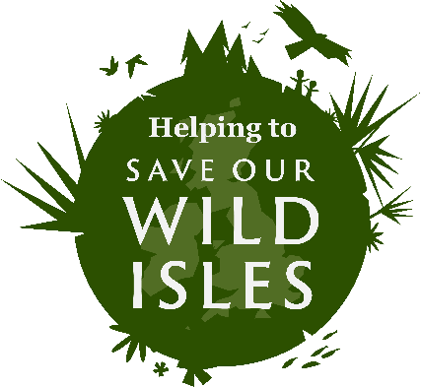
The Wild Isles Community Fund is supporting local communities to take action for nature.
Inspired by David Attenborough’s call to action in the BBC TV Series Wild Isles, Aviva created the fund in partnership with the RSPB and WWF to make it easier for communities across the UK to improve nature in their local area.
The funding is for not-for-profit organisations who can raise their initial funding through a crowdfunding campaign for projects that protect and restore nature in local communities.
From March 30th 2023 £1’000’000 has been allocated in match funding:
- 2:1 match funding will be applied to all* money raised during your crowdfunding period (each £1 raised will be matched with £2 from the fund).
- *Donations of up to £250 will be matched.
- * The maximum of 2:1 funding a group can receive is £5000 (so if you aim to crowdfund £2500, the Wild Isles fund will match this funding at £5000, giving you an overall budget of £7500 for the project).
Who can apply?
Areas of deprivation ranked 1-5 on the IMD Scale: https://www.fscbiodiversity.uk/imd

Your community cause needs to be focussed on taking action for nature – including promoting nature restoration, community connection to nature, and creating positive benefits for our landscape.

- Charities
- Charitable Incorporated Organisations (CIO)
- Community Interest Companies (CIC)
- Companies Limited by Guarantee (CLG)
- Community Amateur Sports Clubs (CASC)
- Constituted Community Groups

If your project doesn’t fit the criteria above but you still want to take action, take a look at the Aviva Community Fund which is open to a much wider range of projects. https://www.avivacommunityfund.co.uk/

What type of projects will be funded?

The Wild Isles Community Fund is committed to supporting communities in areas where the need is greatest, specifically areas that are ranked 1-5 according to the Index of Multiple Deprivation in England, Scotland, Wales or Northern Island.

Projects in the following three categories will be considered:

Nature Restoration | Natured Connectedness and Pro-environmental Behaviours | Community Cohesion and Connection
Activity that boosts local biodiversity by protecting or restoring habitats. | Action that supports greater connection to nature and promotes pro-environmental behaviours at the community level that will benefit nature. | Nature positive activity that encourages collaboration in the local community by connecting people of diverse backgrounds, generations and abilities to nature and one another.
Creating space for nature.
Connecting green spaces.
Addressing activities that directly impact biodiversity.
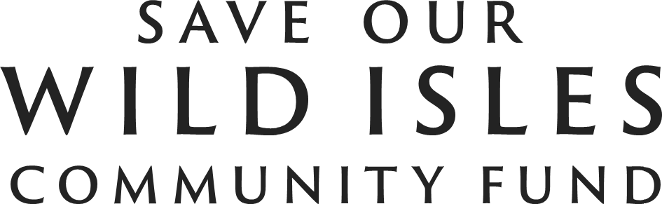

How does the Save our Wild Isles Community Fund work:

- Take Part; applications are now open! Funding is available for organisations looking to deliver projects to protect and restore nature in their local communities.
- Take a closer look; when applying you’ll see the eligibility requirements – check these closely to make sure you meet the criteria.
- Ready to take off; You can use this time to look through the support and resources on offer to help you tell your story, prepare your project page and make the most of your campaign.
- Take it away; launch your fundraising campaign with your network of supporters to raise public donations.
- Take them on a journey; People have donated, they’ve connected with your cause. They’ll be interested to see how things progress so be sure to keep your donors informed and engaged with the great things you’re achieving.
- Take your target further; Reached your original fundraising target early? Set a stretch target to see if you can get some extra support rolling in.
- Take it to the next level; The fundraiser is over – have you reached your target? Congratulations! You’ll have the funds and a whole bunch of new supporters wanting to help your cause.

- There are no deadlines. Applications can be made until all the funding is allocated

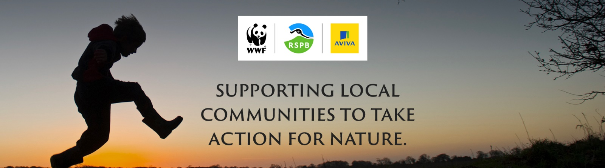

The application form as well as further guidance information can be found online:
https://www.saveourwildisles.org.uk/community/fund
Groundwork staff are available to support applications; for example, we could give you advice on what to apply for, answer any questions about what to include on the form, or give feedback on a draft application. If you need any further information, please don’t hesitate to contact me.
Emily Croft, 07872 857 196, emily.croft@groundwork.org.uk

