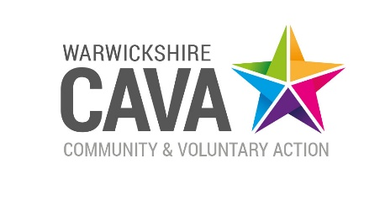

**Expression of Interest**

**Warwickshire County Council Smoking Cessation Programme**

**Provision of Smoking Cessation Advice**

WCAVA has been commissioned by Public Health to work with VCSFE organisations to improve local community engagement in the Warwickshire Smokefree Generation Programme in Warwickshire between April 25 – March 26.

The programme aims to increase numbers of smokers accessing support to quit smoking and is particularly focused on the following priority groups:

* People from low-income households or experiencing socio-economic disadvantage
* Individuals with mental health conditions
* People with substance misuse disorders or co-addictions
* Those with health conditions caused or worsened by smoking
* Individuals with multiple or complex needs
* People experiencing homelessness
* Those in contact with the criminal justice system
* Members of the LGBTQ+ community
* Pregnant women and families with young children in the home

**Funding** of £200 per short programme is available to community centres and groups to:

- promote the Smokefree campaign and services using resources provided

- train frontline staff to provide Very Brief Advice (VBA) and to become smokefree

champions using the online resources available from [NSCT and/or MECC training (and local Children and Young People MECC).](https://link.edgepilot.com/s/594d22d9/Kfn3uGy32k6dOr5-gg2YcQ?u=https://elearning.ncsct.co.uk/vba-launch)

- deliver a wellbeing/wellbeing sessions that include smoking cessation advice, particularly to the priority groups

**Outputs** from the funding to be reported against include:

* Number of frontline staff trained
* Number of people attending wellbeing sessions provided with VBA on smoking cessation
* Number of wellbeing sessions held that include smoking cessation advice
* Number of people attending the sessions

**Expected outcomes** include:

* Increased awareness of the Smokefree Campaign
* Enhanced skills of frontline staff to provide effective smoking cessation advice.
* Higher referral rates of smokers to local stop smoking services.
* Overall reduction in smoking prevalence across the county

**Expected start date**: 31st October 2025

**Reporting Deadline**: 1st March 2026

**Apply**

WCAVA is seeking Expressions of Interest from a wide variety of organisations across the county; successful applicants will be restricted to four per local authority area in line with available funds.

Please summarise on no more than two sides of A4 what you can offer to meet the requirements of the funding and how you meet the Outputs and Outcomes required.

CAVA may need to do due diligence checks with each provider around insurance and core policies, applicants must be willing to provide documentation on request.

Please submit completed EOIs to [pippa.reeve@wcava.org.uk](mailto:pippa.reeve@wcava.org.uk) by 30th September 2025

If you require further information on the opportunity please contact [pippa.reeve@wcava.org.uk](mailto:pippa.reeve@wcava.org.uk)