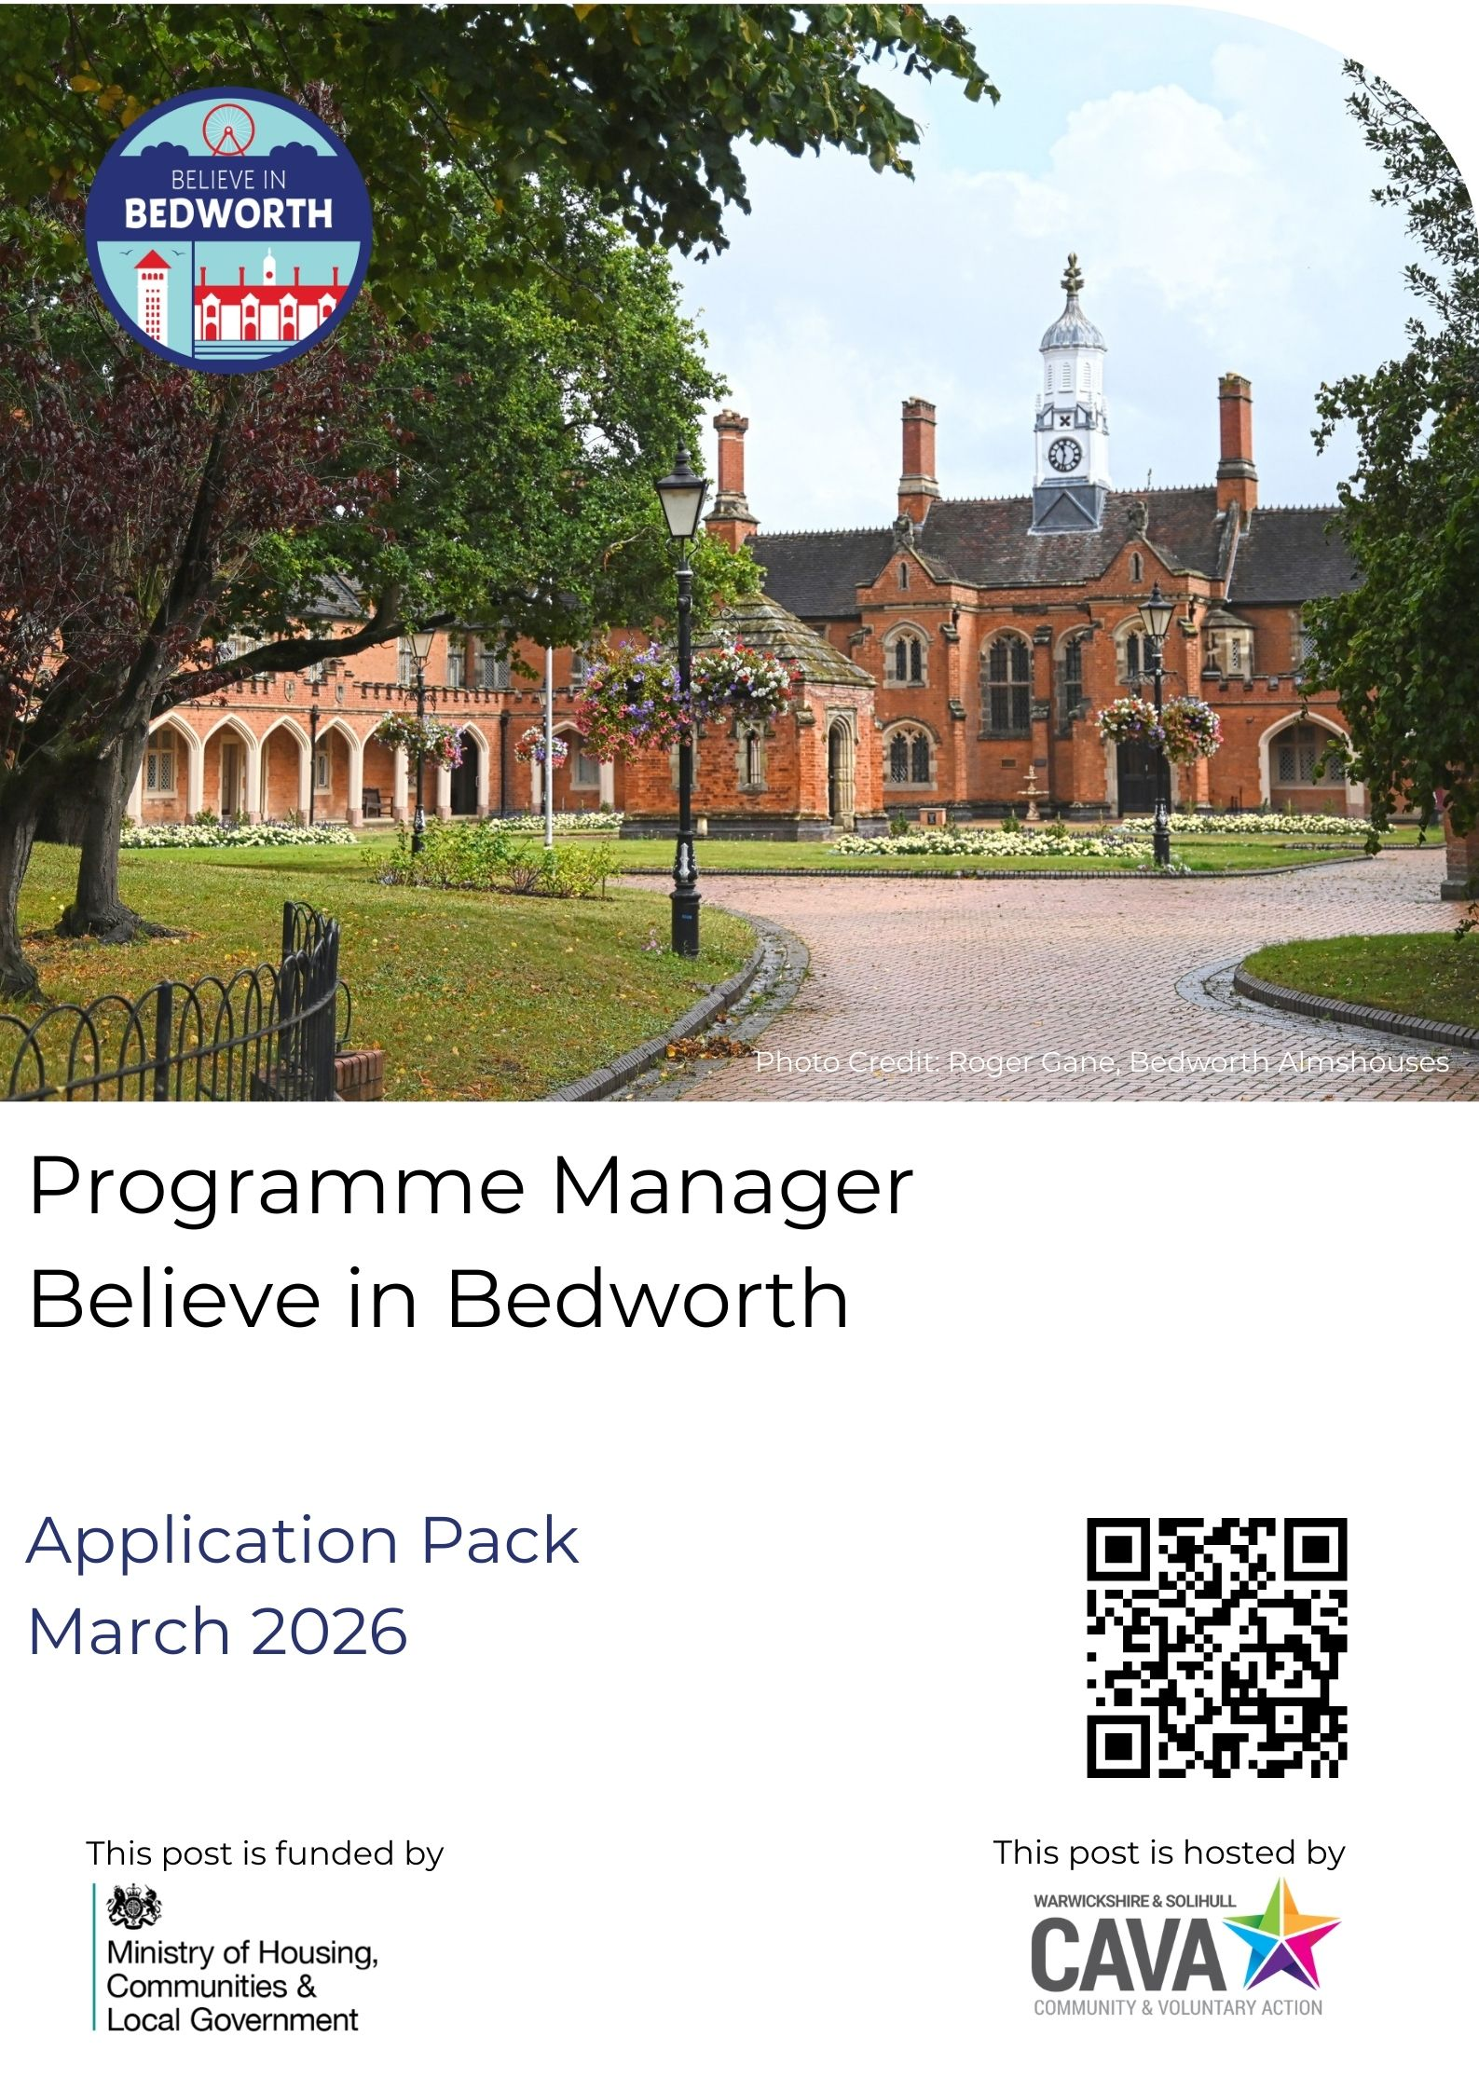
WELCOME

Thank you for your interest in becoming the first Programme Manager of the Believe in Bedworth programme.

As 1 of 75 areas eligible for Pride in Place (round 1) funding from by the Ministry of Housing Communities and Local Government (MHCLG), Believe in Bedworth marks a new chapter for the town, its people and place. Our shared mission is simple: to empower local people to shape the future of their neighbourhood.

Together, as a Board of civic, business and social partners, we are building a project that places empowerment and change directly in the hands of the people who live and work here. The Programme Manager will lead in bringing this to life, managing a small team, working with residents, partners and businesses to co-create a programme that builds pride, connection and opportunity. You will help write the next chapter of our story at a moment of real transformation in the Borough.

You must be passionate about driving positive change within communities, thrive in collaborative environments, and be a motivated, dynamic individual with strong project management experience to join our team. If you share our belief that community participation can transform people and places, we would love to hear from you.

If you think you fit the brief for this exciting role, please view the full Job Description and submit your CV, a covering letter, details of 2 referees and completed Monitoring Form (pages 8-9) to recruitment@wcava.org.uk; please bear in mind the cover letter should evidence your ability to meet the requirements of the role, and forms an essential part of our shortlisting process.

The deadline for applications is 9am, Monday 23rd March 2026. Interviews will be held on Wednesday 1st April 2026 in Bedworth.

No agencies please.

CAVA is an equal opportunities employer – ‘Putting Equality, Diversity and Inclusion into Practice’.

A charitable company limited by guarantee, registered in England & Wales, no. 06531268. Registered charity number 1123402.
What is Pride in Place?

Pride in Place is a central Government initiative designed to develop stronger communities thriving places and allowing residents to take back control. Each programme is unique to its place, shaped by local people and partnerships, and focused on long-term, community-led change.

About Believe in Bedworth

Believe in Bedworth is 1 of 75 Phase 1 Pride in Places areas. A Board was brought together to develop a compelling Regeneration Plan and Investment Strategy that identified local need and established a strong framework which you will take forward into delivery.

The programme, via the accountable body Nuneaton and Bedworth Borough Council, will receive £20m from MHCLG over 10 years, 2026-2036. It may also benefit from other external investment and in-kind support from across local partners. There is a Neighbourhood Board who will give local people the power to decide how funding is used, putting communities in charge of the future of their neighbourhoods.

Why is it called Believe in Bedworth?

Bedworth has a strong identity and sense of place; a proud area, steeped in tradition and history, therefore the programme is a positive affirmation of how we want residents, businesses and partners to feel about Bedworth now, and in the future.

About the role

As Programme Manager you will help to build and line-manage a newly established team, which will include a Community Development Worker and an Administrator. These new roles will be shaped by you, in collaboration with the Neighbourhood Board. You will play a key role in designing how this team operates, while drawing on the wider expertise, systems and support of CAVA.

You will be based in Bedworth, Rugby and Nuneaton Citizens Advice (BRANCAB’s) Bedworth office, but will work with and be supported by colleagues from across CAVA. You will report to CAVA’s North Area Manager who is also a member of the Neighbourhood Board. You will play a vital role in maintaining transparency, accountability and collaboration between the organisation and the Neighbourhood Board, whilst also ensuring alignment with CAVA’s charitable objectives and values.

The Neighbourhood Board

As Programme Manager, you’ll work with the Board, who each bring experience, insight and commitment to Bedworth’s communities. The Board has an Independent Chair, the Chief Executive of BRANCAB, the MP for Bedworth is a member, as well as other local charity representatives, businesses, and an elected member from each Nuneaton and Bedworth Borough and Warwickshire County Councils. Together, these partners will be your key collaborators, offering strategic guidance, support and shared purpose.

About CAVA

CAVA is the local Voluntary, Community, Fath and Social Enterprise (VCFSE) Sector infrastructure organisation for Warwickshire and Solihull, providing vital support to the volunteers, groups, organisations, social enterprises and charities who are working to strengthen all our communities. Every year our dedicated teams of staff and volunteers help lever in significant investment into the area. In 2024/25 the collective value of funding secured for VCSE sector was nearly £6m, and the economic value volunteering opportunities was just under £5m. We are committed to providing all our services locally and accessibly, whether a group or individual need support accessing volunteering opportunities, developing a community group, accessing funding or strengthening governance, we have a local office and dedicated team within easy access.

About working for CAVA

- Salary: All new starters commence their employment on the entry level of the salary scale with an annual incremental increase. CAVAs Board of Trustees may from time to time consider the application of cost of living increases.
- Contract Term: Whilst this is a fixed-term contract, there may be potential to extend the role subject to securing further investment. All appointments are subject to the satisfactory completion of a 6-month probationary period.
- Annual Leave: 26 days plus bank holidays plus an extra day for each completed holiday year of service to a maximum of 5 additional days after five holiday years of service. Entitlements for part time employees are pro rata to hours worked.
- Additional Leave: Supportive policies around sick leave and pay, unpaid leave, compassionate leave and dependent care leave.
- Pension: Minimum 5% employee contribution and 3% employer contribution, with an ethical investment policy option.
- Expenses: Reasonable out of pocket expenses are paid, including mileage costs associated with carrying out duties of the role.
- Employee Development: There will be training, development and support opportunities through CAVA and Pride in Place networks.
- Flexible Working: We are open to discussions around flexible working opportunities, e.g. job sharing, term-time working, that meet the needs of both the organisation and the individual.
- Health and Wellbeing: Regular health and wellbeing days and an employee assistance package.
- Safeguarding: The role involves regular engagement with community members, appointment is subject to a satisfactory Enhanced DBS check.

What our team say about working with us:

“Being part of a team who work well together and are supportive of each other professionally and personally. Also varied nature of my role and great work/life balance. I also really appreciate the good holiday allowance, sickness terms etc.”

“The variety of the job, the office environment, good team working and opportunities for development I also appreciate the opportunities I have to be creative in terms of being able to suggest new ideas/projects etc.”

“I love the vibrant environment of working with people who are a passionate about the sector as I am. I always feel like I am treated as a ‘whole person’ not just an employee. I always do and always have loved worked for CAVA. Teamwork is always positively encouraged and respected and as such, 'We' make a very strong team”

“The atmosphere in the organisation - one which is understanding, flexible, adaptive, inclusive, and interested in people (both its' customers/clients, and employees and volunteers) - makes working for CAVA a joy and a privilege”

JOB DESCRIPTION

Post Title: Believe in Bedworth Programme Manager

Responsible to: Believe in Bedworth Neighbourhood Board

Reports to: Area Manager, North - CAVA

Direct Reports: Staff and volunteers within the project as agreed

Hours: 30 hours per week, with some evenings and weekends

Location: Office/Hybrid (BRANCAB offices, Bedworth) with regular travel around Bedworth

Duration: Fixed term for 3 years with potential to extend subject to funding

Salary: £40,314 per annum, pro rata

Main Purpose of the Job

The Programme Manager will support and advise the community-led Believe in Bedworth Neighbourhood Board, you'll be at the heart of shaping vibrant, sustainable neighbourhoods by assisting successful strategic planning, governance, and project delivery. You'll enable local communities and stakeholders to engage, and influence the Board and make sure projects, schemes and commissions are delivered on time, within budget and achieving the programme's intended outcomes and expectations, whilst aligning with other local, regional and national initiatives.

The first year will be focused on setting firm foundations for long-term, community-led growth, and subsequently, promote partnerships, whilst embedding co-creation and inclusion at all levels.

The postholder will lead a small team and support the connections between the Board and the communities the programme will serve in Bedworth.

Values and Attitude

All employees are expected to demonstrate CAVA’s values by working positively as part of a team, delivering high quality services where all are supported and encouraged and to promote an ethos which values and encourages equality and diversity within the organisation. The Role holder will continue to support the relationships and respect held by CAVA throughout the Voluntary, Community and Social Enterprise (VCSE) sector in Warwickshire and Solihull.

Main Duties and Responsibilities

Team and operations:
- Recruit, lead and manage the project staff and volunteers.
- Work closely with the Neighbourhood Board, ensuring transparent governance, shared decision making and accountability.
- Ensure Board meetings and any sub-groups are well-organised and informed by accurate reporting.
- Provide regular updates to CAVAs leadership team, trustees and members as necessary.
- Ensure the timely delivery of reports to funders and maintain accountability.
- Act as the representative and spokesperson where necessary for the project and Board.
- Ensure all delivery programmes meet safeguarding good practice.

Oversee programming and community decision making:
- Embed consultation and co-creation in all stages of planning and delivery.
- Establish and support any community steering groups or panels.

Oversee the effective management of resources to deliver programme objectives:
- Programme management of work relating to projects and ensuring they are delivered in accordance with agreed project and investment plans, within identified resources and that information is managed appropriately.
- Working with the Board, ensure that the programme meets its financial targets and responsibilities.
- Undertake regular reporting to the Board, which will include financial, risk and highlights, to ensure the successful delivery of programme objectives as determined by the Board.
- Bring in additional specialist expertise or capacity as and when required.
- Lead comprehensive data collection and engagement monitoring to assess impact and ensure the project is achieving its intended outcomes.

Manage partnerships and stakeholder relationships:
- Develop and maintain partnerships and stakeholder relationships.
- Act as a broker for new opportunities, for example locally or nationally through sports, education, health and the private sector, securing additional funding or developing new collaborations.
- Ensure the input of appropriate collaborators, be that local authority officers, partners or advisors to ensure the programme and associated projects are developed within agreed parameters.
- With support as necessary, develop and lead on a responsive and inclusive marketing and engagement strategy, with communities, partners, Elected Members, MP and other stakeholders.
- Ensure that project learning is shared locally and nationally, participating in any national peer learning forums.

General
- Ensure Believe in Bedworth activities work towards the objectives for delivery of MHCLG’s Pride in Place strategy.
- Ensure the work is compliant with relevant regulations, policies, and procedures, including data protection, health and safety, and funding requirements.
- Adhere to the policies and procedures of CAVA.
- Undertake training and development as appropriate and actively participate in performance management reviews.
- Contribute towards wider CAVA and partner events and activities as appropriate.

PERSON SPECIFICATION

The successful candidate will need to demonstrate:

CRITERIA | E or D =  Essential or Desirable | Assessed:  A = Application form  I = Interview  T = Test at Interview
WORK EXPERIENCE |  | A | I | T
Minimum two years’ management experience, with demonstrable strength in project management. | E | x | x
Experience of working in a VCFSE setting. | D | x | x
Working in areas with diverse communities. | E | x | x | x
Engaging communities as decision makers, developing, managing and delivering participatory programmes that respond to local needs. | E | x | x
A strong understanding of evaluation methodologies and using data, insights and analysis to drive decision making and evidence programme impact. | E | x | x
Strong financial management skills, including responsibility for budgets. | E | x | x
Ability to develop, sustain and build genuinely collaborative relationships across complex partnerships, especially working alongside local authority partners. | E | x | x
Experience of levering in additional funding to complement project delivery. | E | x | x
Experience of aligning programmes and opportunities to maximise value and mutual impact | E | x | x
Experience of event planning and management. | D | x | x
QUALIFICATIONS/KNOWLEDGE
Ability to work with IT systems and processes such as MS 365. | E | x
Knowledge of VCFSE sector. | E | x
Knowledge of Nuneaton and Bedworth Borough. | D | x | x
Understanding of and implementing marketing strategies. | D | x
SKILLS AND ABILITIES
Excellent stakeholder management skills, with the ability to engage confidently with a wide range of partners. | E | x | x | x
Holds self and others accountable for delivering agreed objectives and standards. | E | x | x
A demonstrable commitment to equality, diversity and inclusion across all aspects of work. | E | x
Strong leadership skills with the ability to inspire, empower and support others to achieve shared goals. | E | x
Excellent communication skills, both written and verbal, with experience in report writing and presentation. | E | x |  | x
Friendly, approachable and objective both within partnership working and as a team-member. | E | x | x
Self-motivated with ability to work to deadlines as an individual and alongside partners and stakeholders. | E | x
Flexibility to work different days/hours occasionally. | E | x

MONITORING FORM

CAVA is committed to being an Equal Opportunities organisation and would like to monitor the effectiveness of its Equal Opportunities Policy in the recruitment and employment of staff. This includes not discriminating under the Equality Act 2010. This form will be separated from your main application and will not be seen by the recruitment panel. Completion of this form is voluntary. If you do not wish to answer any of the questions you can select the “prefer not to say” option.

By providing the information requested on this form, you are giving your consent that it may be processed and handled under the Principles of Data Protection as detailed in the Data Protection Act 1998, the General Data Protection Regulations (EU 2016/679) (UK GDPR) and any subsequent legislation as appropriate for the purposes of Equal Opportunities monitoring.

Data will be collated anonymously and used only for monitoring purposes. The form will be destroyed once the data has been collated in accordance with our records retention policy. You may withdraw your consent at any time by contacting us as below. For more information on how we use the information you have provided, please see our privacy notice.

If you have any questions about the form, please contact recruitment@wcava.org.uk.

Please return the completed form, along with your CV and covering letter, to recruitment@wcava.org.uk.

Post Title Believe in Bedworth Programme Manager

Gender

Male Female Intersex Non-binary Prefer not to say If you prefer to use your own term, please specify here

Disability

Do you consider yourself to have a disability or health condition?

Yes No Prefer not to say

What is the effect or impact of your disability or health condition on your ability to give your best at work?

The information in this form is for monitoring purposes only. If you believe you need a ‘reasonable adjustment’ please discuss this with the manager running the recruitment process.

Ethnicity

Ethnic origin is not about nationality, place of birth or citizenship. It is about the group to which you perceive you belong. Please tick the appropriate box

White

English Welsh Scottish Northern Irish Irish British Gypsy or Irish Traveller

Prefer not to say

Any other white background, please specify:

Mixed/multiple ethnic groups

White and Black Caribbean White and Black African White and Asian Prefer not to say

Any other mixed background, please specify:

Asian/Asian British

Indian Pakistani Bangladeshi Chinese Prefer not to say

Any other Asian background, please specify:

Black/ African/ Caribbean/ Black British

African Caribbean Prefer not to say

Any other Black/African/Caribbean background, please specify:

Other ethnic group

Arab Prefer not to say

Any other ethnic group, please specify:

Religion or belief

No religion or belief Buddhist Christian Hindu Jewish Muslim Sikh Prefer not to say

If other religion or belief, please specify:

Age

16-24 25-29 30-34 35-39 40-44 45-49 50-54 55-59 60-64 65+

Prefer not to say

Sexual Orientation

Heterosexual Gay Lesbian Bisexual Prefer not to say

If you prefer to use your own term, please specify here:

Where did you see this post advertised?

WCAVA locality office window WCAVA Website Direct contact from WCAVA Facebook

Twitter Linkedin Indeed WMJobs Charity Jobs Other (please specify)

Any comments on the pack/process as a whole

Thank you for your comments – you will help us to improve our future application process.

